Setup Maven Project :

1. Create a maven project.

2. Configure the pom.xml - Add surfire plugin.

3. Add sample testcases under src/test/java.

4. create 3xml files and add tests in that.

5. Run single testng.xml.

6. Run multiple xml files.

7. Run multiple xml files in parallel.

Denilo manam more than one testng.xml files create chestamu vatiki manam names ela estamu :

1. sanity.xml

2. smoke.xml

3. coverage.xml

4. regression.xml

e session lo vetini single ga and combined ga and parallel ga ala run chiyali aneadi ekada chustamu.

vitini run cheasea process :

create maven project --> add surefire-pugin --> create some packages and testcases under src/test/java --> create 3xml files --> run singely and combinedly and parallely.

vaka vela ani xml's vakea sari run aavali antea vaka testng.xml file createa cheasi dani rename like automation.xml cheasi aa name pom.xml file lo surefire plugin kinda configuration lo estamu like below :

<plugin>

<groupId>org.apache.maven.plugins</groupId>

<artifactId>maven-surefire-plugin</artifactId>

<version>3.0.0-M5</version>

<configuration>

<suiteXmlFiles>automation.xml</suiteXmlFiles> -->

</configuration>

</plugin>

How to run multiple TestNG XML Files simultaneously sequentially & in parallel using Maven pom.xml

1. How to run multiple TestNG XML files in a Single Run ?

manam 1st vaka testng.xml file vakati create cheasukoni dani rename chestamu like sanity.xml ani tarvata dani pai right click echi run as testng test ani click chestea aa xml file run

iedi.

aa single.xml file lo ela evali

<test thread-count="5" name="Test">

<classes>

<class name="package1.Test1"/>

</classes>

</test> <!-- Test -->

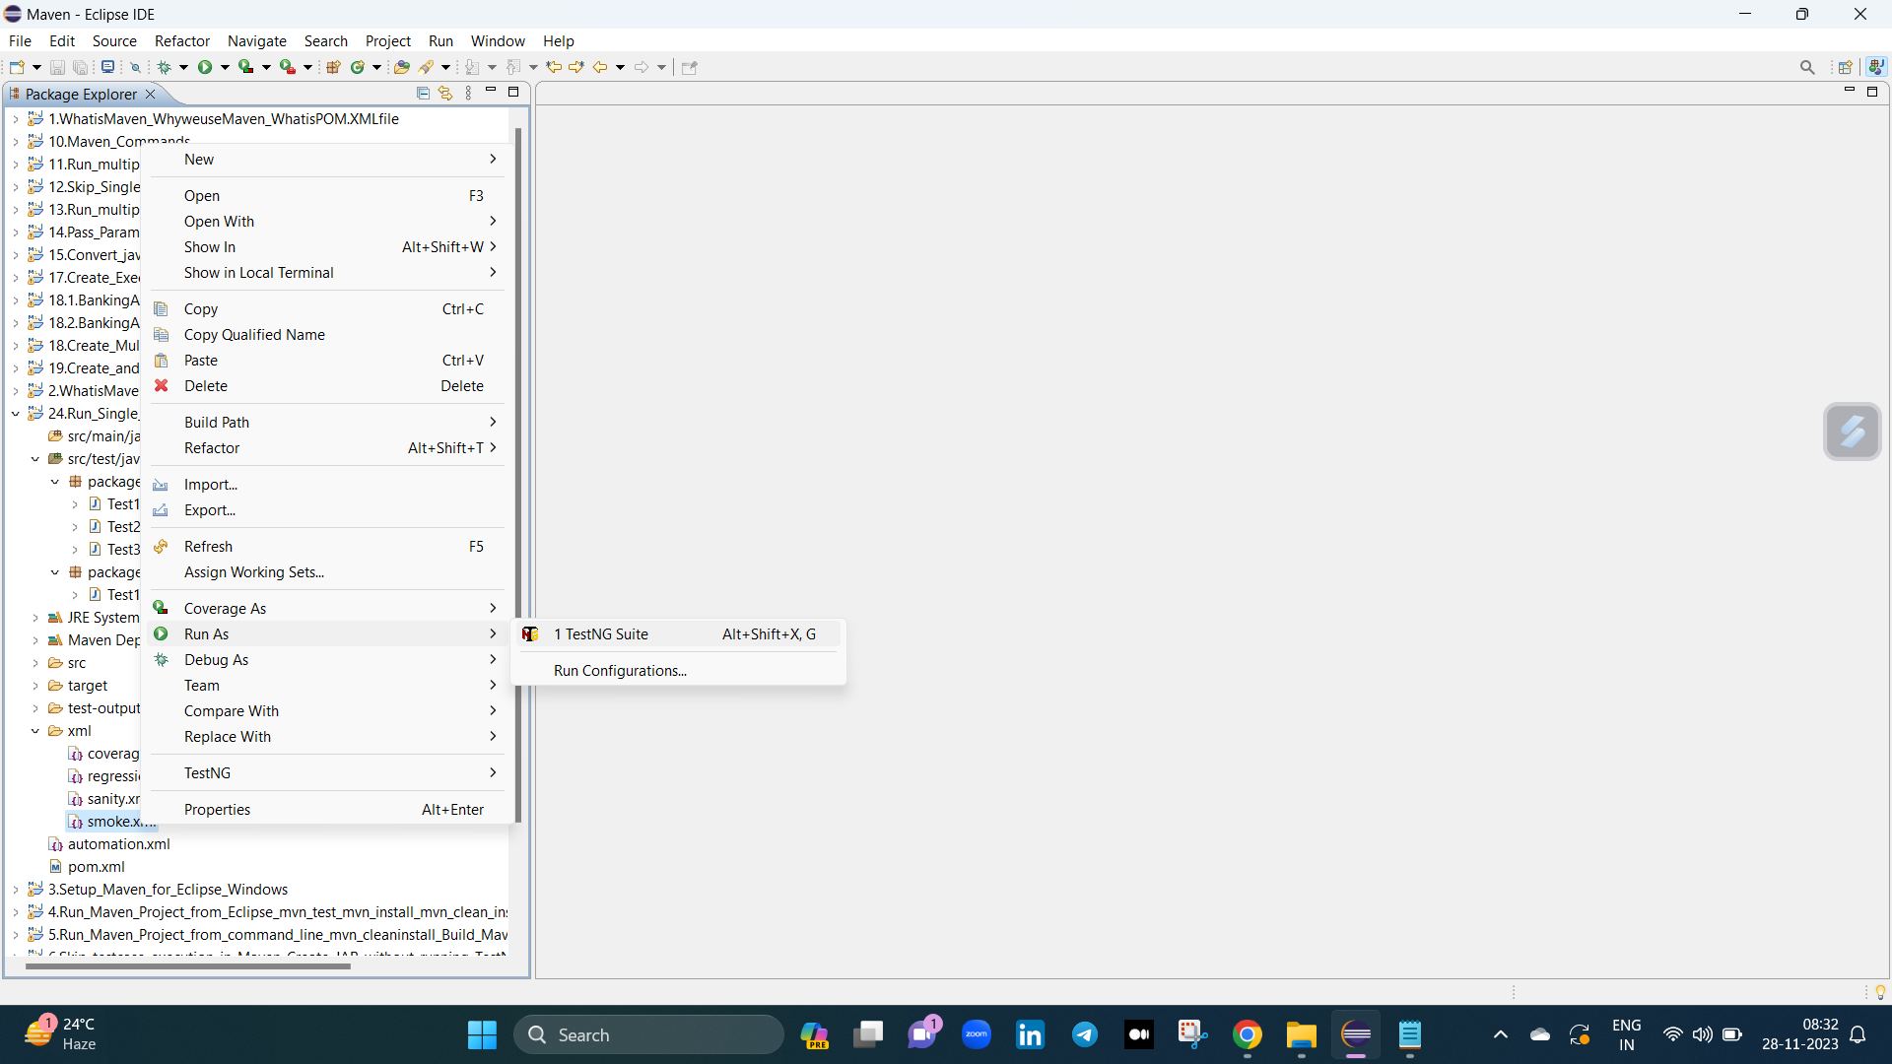

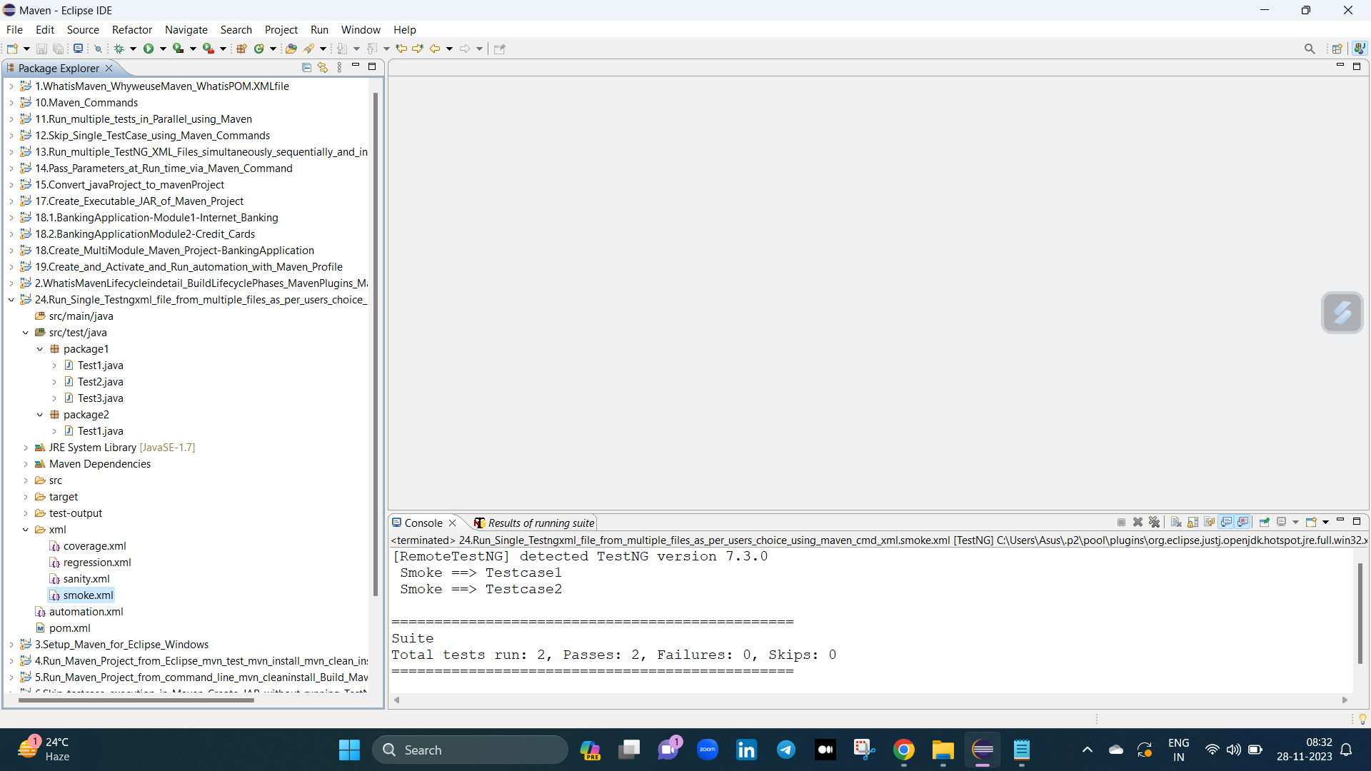

2. How to run multiple TestNG XML files simultaneously using POM.XML ?

manam 1st 4 testng.xml files createa cheasukoni vatini rename chestamu like sanity.xml, smoke.xml, coverage.xml, regression.xml tarvata dani pai right click echi run as testng test ani

click chestea aa xml file run iedi.

adea ani testcases combine cheasi run chaiyali antea testng.xml file lo ela evali

<suite name="AutomationSuite">

<suite-files>

<suite-file path="xml/sanity.xml"></suite-file>

<suite-file path="xml/regression.xml"></suite-file>

<suite-file path="xml/smoke.xml"></suite-file>

<suite-file path="xml/coverage.xml"></suite-file>

</suite-files>

</suite> <!-- Suite -->

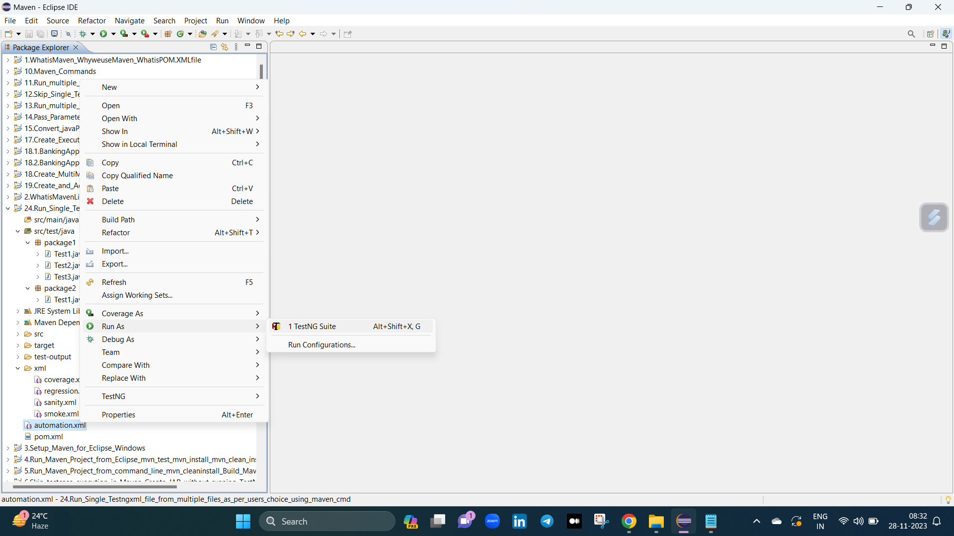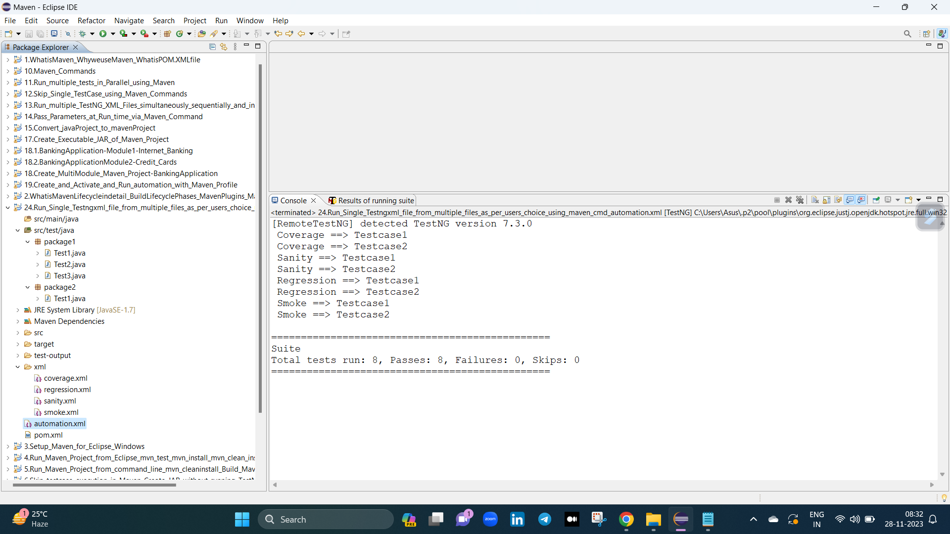

3. How to run single TestNG XML files in Parallel mode using Maven Pom.xml ?

One way :

edi run chaiyali antea manm properties lo vakati add cheasukovali

<properties>

<file>xml/smoke.xml</file>

</properties>

edea properties file ni surefire plugin lo "suitexmlfiles" anea tag kinda suitexmlfile lo evali like below :

<suiteXmlFiles>

<suiteXmlFile>${file}</suiteXmlFile>

</suiteXmlFiles>

epudu run chestea manam profile kinda a xml file echamo adi run iedi.

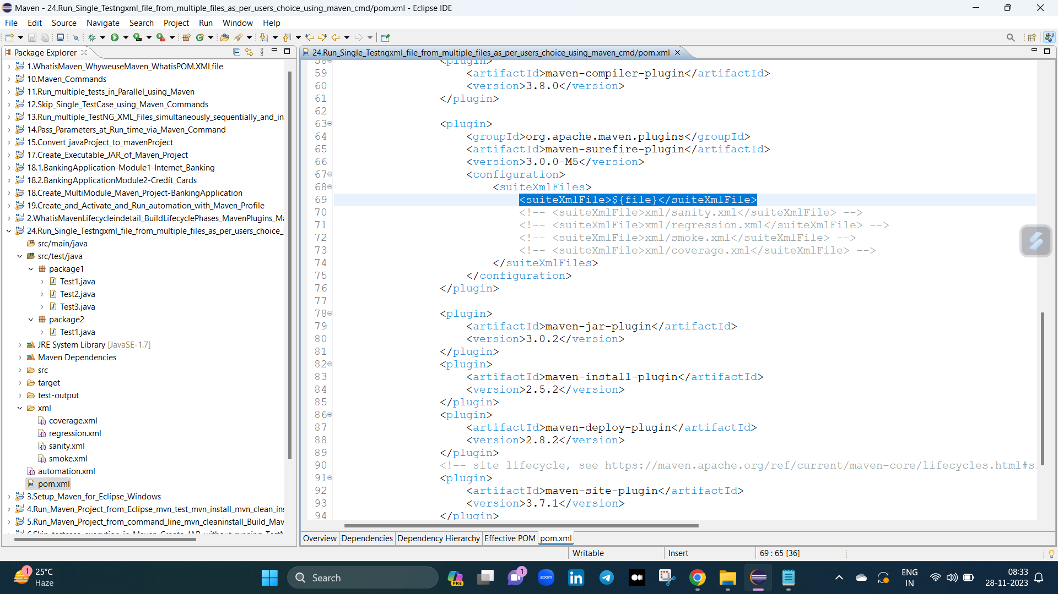

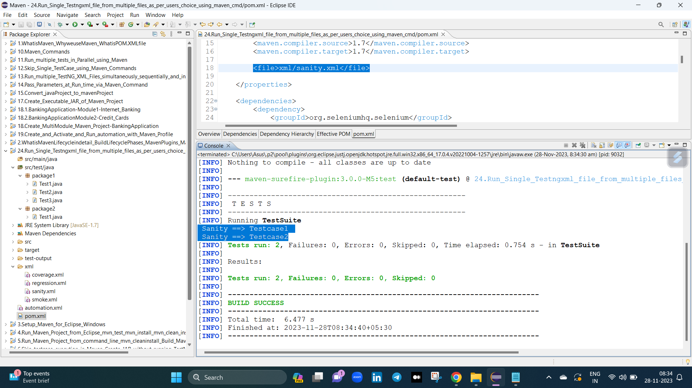

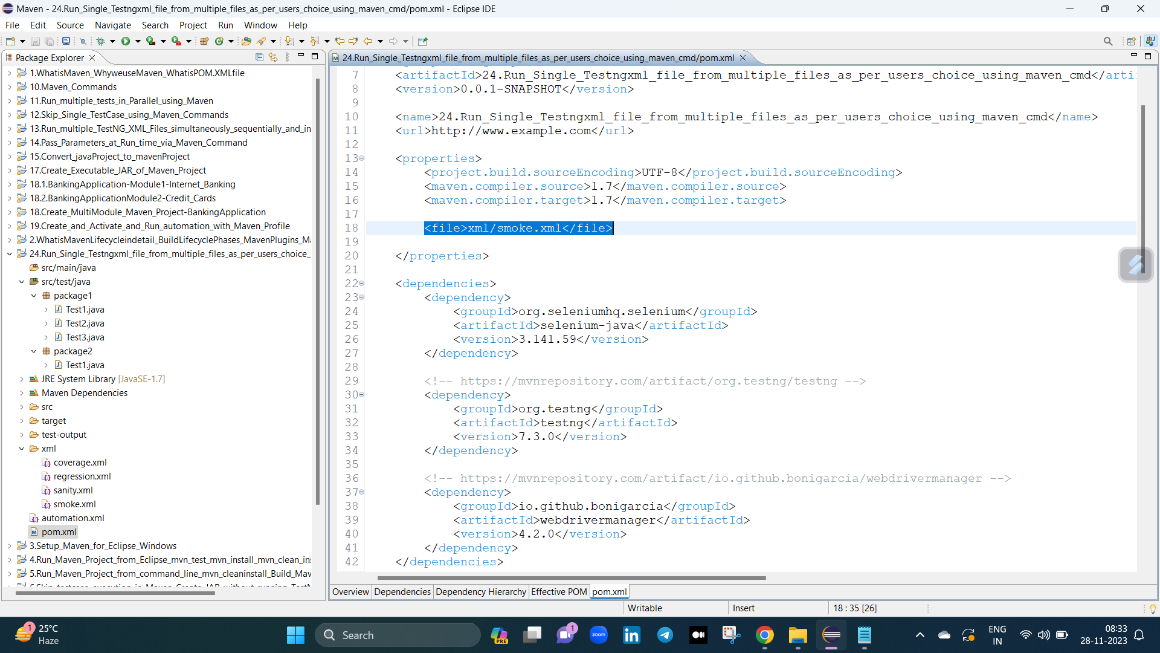

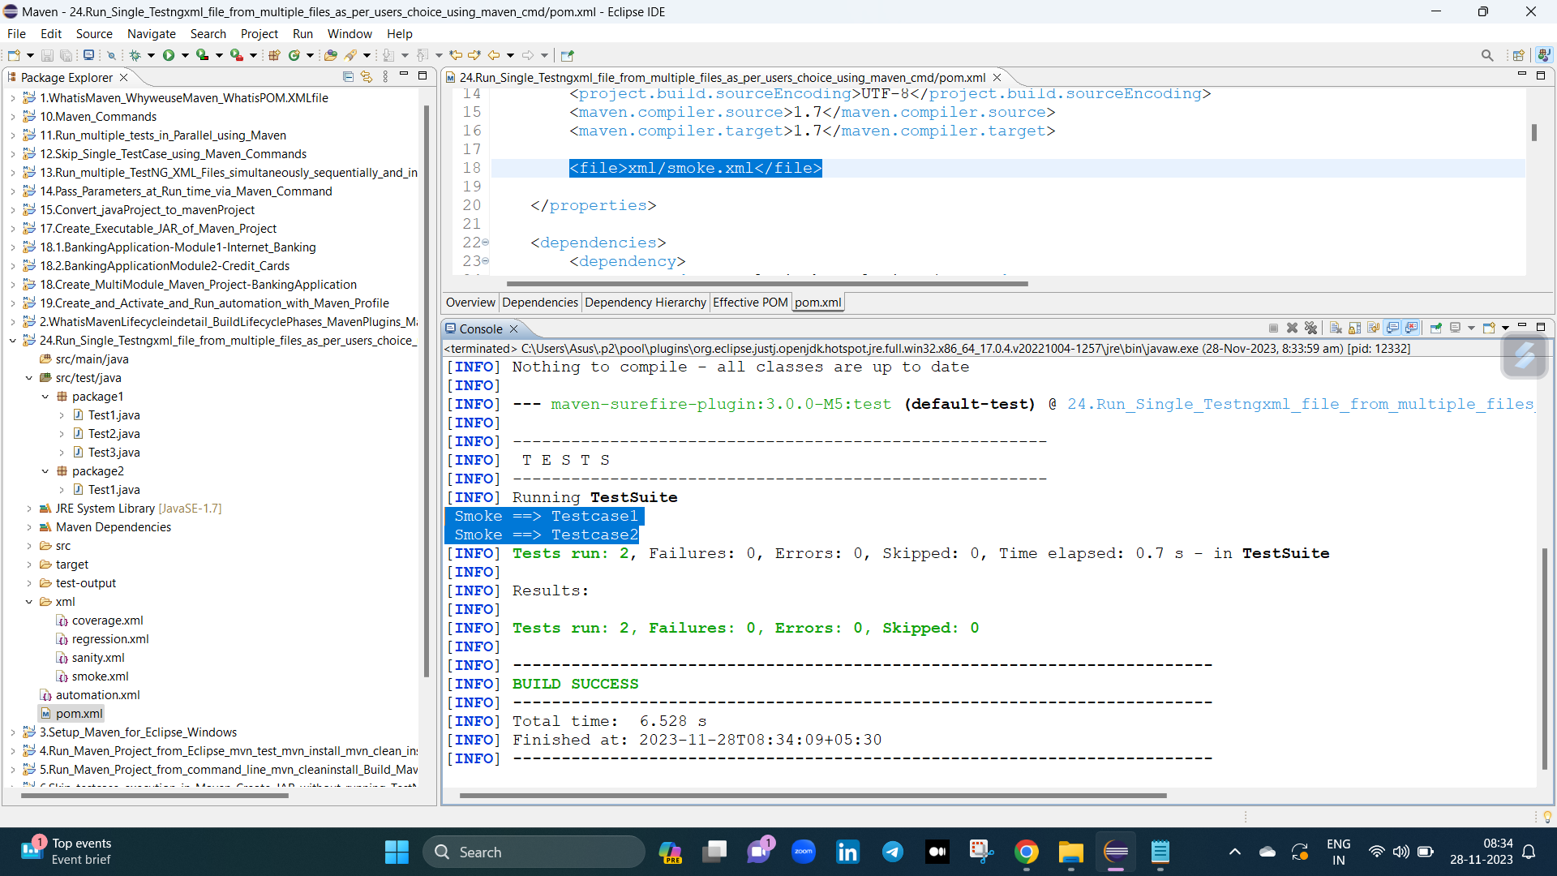

ela kakunda only maven build tho single file ni run chaiyali anteafollow below method :

Second way :

project pai right click echi --> run as --> maven build --> mvn test -Dfile="xml/sanity.xml" (or) mvn test -Dfile="xml/smoke.xml" (or) mvn test -Dfile="xml/regression.xml"

adi estea only xml ki sambandinchina test cases a run aavutai.

deni venaka logic entantea inka properties tags aavasaram leadu only surefire plugin kinda suitexmlfiles lo e command run iedi.

